Unit 2 - Seminar 2

Seminar Questions:
Read the article by Dong, Y. (2023) ‘Descriptive statistics and its applications’, Highlights in Science, Engineering and Technology, 47, pp. 16–23. and answer the following questions:

What is the primary purpose of descriptive statistics, and how does it differ from other statistical methods?
Descriptive statistics analyze the available data. These can be presented as numerical or graphical.
Descriptive statistics are in contrast to inferred statistics that make predictions from a sample to a population.
The paper implies that it can be used to analyse the relationships between variables in a data set. It lists the measurements available as "central tendency, frequency, position,and dispersion” and categories of “ ratio, intervals, and nominal and ordinal variables”. It also discusses the use of mean, median, variance, standard deviation and percentiles.

According to the paper's analysis of housing prices in Beijing (Table 2), what were the key factors that contributed to the increase in housing prices between 2012 and 2015? Explain how the descriptive statistics helped identify these factors.
There is no way to infer cause and effect on the variables and the house prices. For example, The paper notes that the average floor number increased, which represented the trend of taller buildings. However, it is not clear from the data alone if this was the cause of the increase in house prices and is more likely to be a side effect of the demand for properties.
Similarly the increase in living space size, living rooms and bed room numbers. However, again, it is not possible from the data to know if this was a contribution to the increase in housing prices only that the two showed strong correlation.
The only strong conclusion was that orientation did not represent strong correlation with the increase in house prices.

Explain the difference between mean, median, and mode. Given the sample: 13, 15, 17, 15, 20, 15, 18, calculate all three measures of central tendency.
13, 15, 15, 15, 17, 18, 20
Mean = 16.14
Median = 15
Mode = 15

Mean = sum / n
Median = Middle point = 13, 15, 15, 15, 17, 18, 20

Mode = most frequent = 13, 15, 15, 15, 17, 18, 20

What are the main limitations of descriptive statistics as identified in the paper? Why is descriptive statistics alone not sufficient for comprehensive statistical analysis?
Suggests it’s just a basic tool for summarizing data.
They can not make predictions or analyse trends. Data collection can be time consuming. Suggests combining it with methods such as inferential statistics to draw conclusions.

Based on Table 3 and Table 4 in the stock market analysis section, explain how descriptive statistics (particularly mean values) helped researchers determine the relationship between trust levels and stock market volatility during COVID-19.
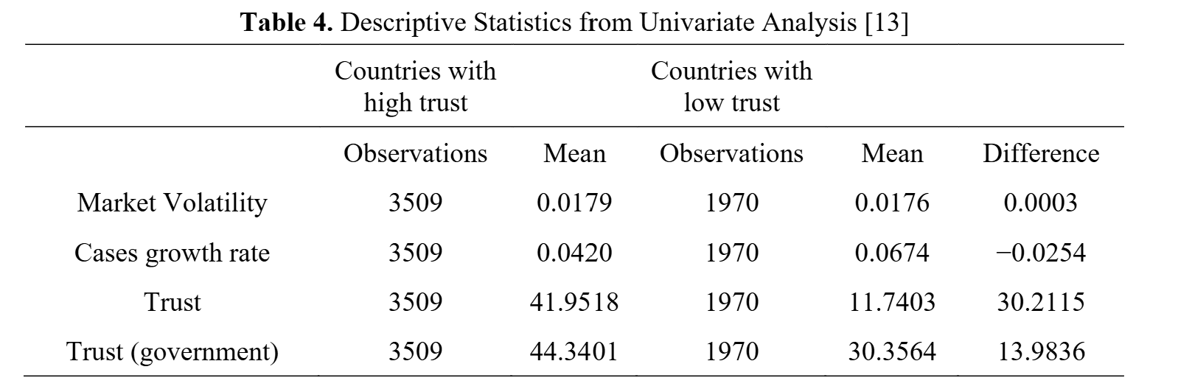
Variable | Mean (High Trust) | Mean (Low Trust)
Market Volatility | 0.0179 | 0.0176
The author concludes that the countries with lower trust have a higher volatility, but the data does not represent that in the tables.

However, the data does show higher growth rates in countries with low trust. This could be what the author is referring to.

Variable | Mean (Growth) | Mean (Growth)
Market Volatility | 0.0420 | 0.0674

Dataset Activity
Using this small covid-19 dataset, perform the following activities:

Calculate and interpret measures of central tendency and dispersion for COVID-19 cases across Indian states during January-March 2020.

Create appropriate visualizations:
- Histograms with density curves for each variable.
- Boxplots to identify outliers.
- Violin plots to show distribution shape.

Observations/Criticisms
Histogram plots were good for visualising data over a time period.
Box plots identify outliers well.
Violin plots help identify trends and show the shape of the data.
Violin plots were not particularly interesting or helpful for data observations on this data set. Maybe more interesting if looking at more data like ages
Statistical significance of the data is unknown. Were more people testing positive because more people were being tested or there were more cases?
Absolute number and not the number per population.
Knowing the number of nationals and non-nationals might not be significant as they don’t have the proportion of nationals and non-nationals per region.
Were the same number of people tested per day in each region?
Violin plots show that it was more likely no one would test positive for covid.
Violin plots per day would not account for things like weekends and an increase on a monday morning. Per week is harder with the short time-frame.

Notes
There was an issue with data: typos meant that some states had multiple names.
# Fix state / union territory names

d1_clean <- d1 %>%
mutate(
`State/UnionTerritory` = case_when(
`State/UnionTerritory` == "Chattisgarh" ~ "Chhattisgarh",
`State/UnionTerritory` == "Pondicherry" ~ "Puducherry",
`State/UnionTerritory` == "Telengana" ~ "Telangana",
`State/UnionTerritory` == "Union Territory of Chandigarh" ~ "Chandigarh",
`State/UnionTerritory` == "Union Territory of Jammu and Kashmir" ~ "Jammu and Kashmir",
`State/UnionTerritory` == "Union Territory of Ladakh" ~ "Ladakh",
TRUE ~ `State/UnionTerritory`
)
)

